1970
Explain why in aqueous solution,
(a) Ti³⁺ is colored but Sc³⁺ is not.
(b) Ti²⁺ is a reducing agent but Ca²⁺ is not.
Answer:
(a) Ti³⁺ forms the octahedral complex, Ti(H₂O)₆³⁺. The lone 3d electron is transferred between the split d-orbitals. Because the d-orbital splitting in most octahedral complexes corresponds to the energies of photons in the visible region, octahedral complex ions are usually colored. Sc³⁺ has no d-orbitals.
(b) Ti²⁺ ion is a reducing agent because it’s 3d² electrons can be easily oxidized. The Ca²⁺ has hard to oxidize 3p electrons.

1970
What is meant by the lanthanide contraction? Account for this phenomenon. Give two examples of its consequences.
Answer:
In the lanthanide series, electrons are filling the 4f orbitals. Since the 4f orbitals are buried in the interior of these atoms, the additional electrons do not add to the atomic size. In fact, the increasing nuclear charge causes the radii to decrease significantly going from La to Lu.
This contraction just offsets the normal increase in size due to going from one principal quantum level to another. Thus 5d elements are almost identical in size to 4d elements. This leads to great similarity in the chemistry of the 4d and 5d elements, such as Hf and Zr being remarkably similar in chemical properties.

1971
There is a greater variation between the properties (both chemical and physical) of the first and second of a group or family in the periodic table than between the properties of the second and third members of the group. Consider as examples either the group containing nitrogen or the one containing oxygen. Select three properties and discuss the variation of these properties to illustrate the generalization expressed in the first sentence of the question.
Answer:
Include discussion of small size and compact electron clouds of the first period atoms. Example properties:
 | N | P | As | O | S | Se
atomic radii (Å) | 0.70 | 1.10 | 1.21 | 0.66 | 1.04 | 1.17
specific gravity (g/cm³) | 0.0012 | 1.82 | 5.73 | 0.0014 | 2.07 | 4.79
melting point (K) | 63 | 317 | 1090 | 55 | 386 | 490

1972
Consider the following melting points in degrees Celsius:
Alkali metals Halogens
Li 181° F₂ -119°
Na 98° Cl₂ -101°
K 63° Br₂ -7°
Rb 39° I₂ +104°
Cs 29°
(a) Account for the trend in the melting points of the alkali metals.
(b) Account for the trend in the melting points of the halogens.
(Make sure that your discussion clarifies the difference between the two trends.)
Answer:
(a) Because of their large sizes and limited numbers of valence electrons, bonding between alkali metal atoms is not as strong as in most metals. Since the atoms increase in size down the family, those near the bottom (Rb and Cs) have the greatest internuclear distances.
(b) Attractive forces between halogen molecules are rather weak, they are of the instantaneous dipole-induced dipole type (London forces), and increase in strength with increasing molecular weight (and increasing numbers of electrons).

1973 D
First ionization Energy
(kilocalories/mole) Covalent Radii, Å
Li 124 1.34
Be 215 0.90
B 191 0.82
C 260 0.77
N 336 0.75
O 314 0.73
F 402 0.72
The covalent radii decrease regularly from Li to F, whereas the first ionization energies do not. For the ionization energies, show how currently accepted theoretical concepts can be used to explain the general trend and the two discontinuities.
Answer:
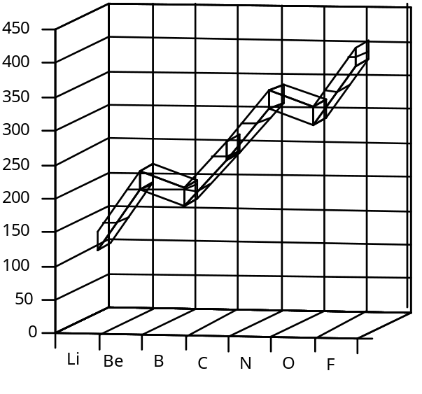
The trend in moving across a period is that the first ionization energy, I₁, increases from group 1 (Li) to group 7 (F) because of an increase in effective nuclear charge, atoms get smaller (decrease covalent radii) and less metallic through the period. The I₁ is less for B than Be because the electron to be ionized in B is in a higher energy orbital (2p) than is the electron (2s) to be ionized in Be. The I₁ is less for O than N because the electron to be ionized in O is a paired electron in the 2p orbitals. At N, the outer sublevel of its atom is half-filled, resulting in a symmetrical spherical electron cloud. The extra electron in O reduces this symmetry and so less energy is required to remove this electron.

1976 D
M(s) + Cl₂(g) → MCl₂(s)
The reaction of a metal with chlorine proceeds as indicated above. Indicate, with reasons for your answers, the effect of the following factors on the heat of reaction for this reaction.
(a) A large radius versus a small radius for M²⁺
(b) A high ionization energy versus a low ionization energy for M.
Answer:
(a) As radius increases the heat of reaction decreases (less exothermic).
Less energy released by ionic attraction (lattice energy inversely proportional to distance).
(b) As ionization energy increases the heat of reaction decreases (less exothermic),
More energy required to form M²⁺ while other factors remain unchanged.

1977 D
The electron affinities of five elements are given below.
₁₃Al 12 kcal/mole
₁₄Si 32 kcal/mole
₁₅P 17 kcal/mole
₁₆S 48 kcal/mole
₁₇Cl 87 kcal/mole
Define the term “electron affinity” of an atom. For the elements listed above, explain the observed trend with the increase in atomic number. Account for the discontinuity that occurs at phosphorus.
Answer:
Electron affinity - the energy released when a gaseous atom gains an electron to form an ion.
As an electron is added to the same valence shell of an atom, when Z increases, the atomic radius decreases. Therefore, the added electron in going from Al to Si and from P to S to Cl is closer to the nucleus and more energy is released (electron affinity greater). Also as the atomic radius decreases, the shielding of the nucleus by the surrounding electrons is less effective, and the attraction for the added electron is greater.
At P, the outer sublevel of its atom is half-filled, resulting in a symmetrical spherical electron cloud. The extra electron reduces this symmetry and so less energy is released when it enters the atom to form P⁻.

1984 D
Discuss some differences in physical and chemical properties of metals and nonmetals. What characteristic of the electronic configuration of atoms distinguishes metals from nonmetals. On the basis of this characteristic explain why there are many more metals than nonmetals.
Answer:
 | metals | non-metals
Physical properties:
melting points | rel. high | rel. low
elec. conduct. | good | insulators
luster | high | little or none
physical state | most solids | gases, liq. or solids
[etc.]
Chemical properties:
redox agents | reducing | oxid. or reducing
 | electropositive | electronegative
oxides | basic or amphoteric | acidic
react with | nonmetals | metals & non-metals
[etc.]

Electron configurations: Metals: Valence electrons in s or d sublevels of their atoms. (A few heavy elements have atoms with one or two electrons in p sublevels.) Nonmetals: Valence electrons in the s and p sublevels of their atoms.
There are more metals than nonmetals because filling d orbitals in a given energy level involves the atoms of ten elements and filling the f orbitals involves the atoms of 14 elements. In the same energy levels, the maximum number of elements with atoms receiving p electrons is six.

1985 D
Properties of the chemical elements often show regular variation with respect to their positions in the periodic table.
(a) Describe the general trend in acid-base character of the oxides of the elements in the third period (Na to Ar). Give examples of one acidic oxide and one basic oxide and show with equations how these oxides react with water.
(b) How does the oxidizing strength of the halogen elements vary down the group? Account for this trend.
(c) How does the reducing strength of the alkali metals vary down the group? Account for this trend.
Answer:
(a) Oxides at left are basic and become less basic / more acidic as one moves to the right.
Basic oxide: Na₂O + 2 H₂O → 2 Na⁺ + 2 OH⁻
or: MgO + H₂O → Mg(OH)₂
Acidic oxide: any one of the oxides of Cl, S, or P
SO₂ + H₂O → H₂SO₃ (or equivalent for another oxide)
(b) Oxidizing strengths of halogen elements decrease down the group. Since atoms get larger down the group, the attraction for electrons decreases and oxidizing strength decreases.
(c) Reducing strengths of alkali metals increases down the group. Since atoms get larger down the group, loss of outer electrons is easier and reducing strength increases.

